Project Architecture

**Project Title**: Image-based Stock Analysis Lens with Object Recognition and Sector Classification

**Version**: 1.0

**Author**: Akshad Kolhatkar

**Date**: 2024-02-09

Table of Contents:

1. Overview
2. Project Goals
3. System Architecture
4. Data Flow
5. Deployment Strategy
6. Conclusion

## 1. Overview

This document outlines the architecture for a project that analyzes images and generates relevant stock market information.

The project aims to analyze images uploaded by users, identify objects within these images using DETR (DEtection TRansformer) and ResNET-50 models, classify the detected objects into specific stock market sectors, and provide information on the top ranked Indian stocks within these sectors along with their current statistics.

## 2. Project Goals

* Develop a user-friendly interface for image upload and visualization of results.
* Implement accurate object detection and classification using deep learning models.
* Use external APIs to retrieve real-time stock data and statistics.
* Provide a comprehensive overview of the stock market landscape based on the image content.

## 3. System Architecture

The system can be visualized into 5 stacks:

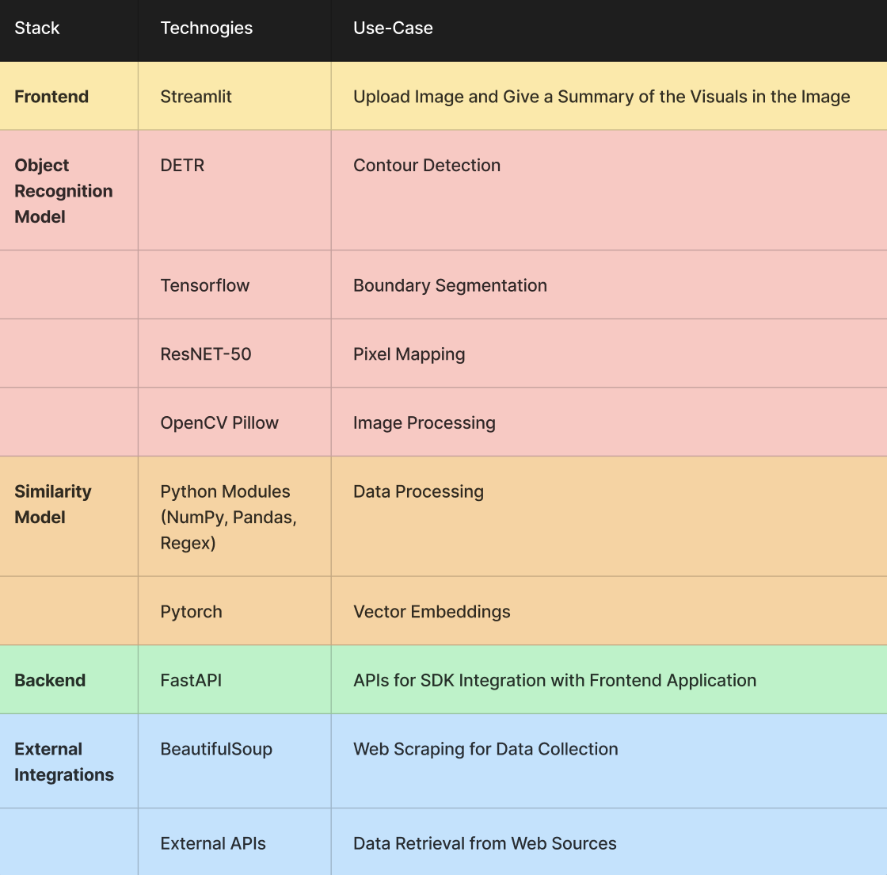

Frontend: User uploads an image through a web interface built with Streamlit.

Image processing and Object recognition: Extracts visual summary and passes image to object recognition model. Uses DETR model with TensorFlow and ResNet-50 backbone to identify objects.

Similarity Model: Classifies objects into stock market sectors using Python modules like NumPy, Pandas, PIL, and PyTorch.

Backend APIs: Integrating all the Models to the Frontend Application.

External Integrations : Stock data retrieval pipeline for fetching current statistics of top ranked Indian stocks in each sector using BeautifulSoup and external APIs.

## 4. Data Flow

* User uploads image through streamlit interface.
* Image is sent to the backend for processing.
* Image summary is extracted and sent back to the front-end.
* Image is passed to the object recognition model, returning a list of identified objects.
* Object list is sent to the entity mapping module, which assigns sectors to each object.
* Sector information and object list are sent back to the front-end.
* External APIs are called to retrieve stock data for each sector's top ranked Indian stocks.
* Stock data is sent back to the front-end and displayed alongside other results.

## 5. Deployment Strategy

The system can be deployed as a web application on a cloud platform like Heroku or AWS. Docker containers can be used to package and isolate different components. Secure connections to external APIs should be established.

## 6. Scope of Improvements

* Contour Detection Model
* Current Objects Data Dictionary Vocabulary
* Similarity Algorithm
* AutoML Self-Learning Capabilities

## 7. Conclusion

This document provides an overview of the architecture for an image-based stock analysis lens project. The system leverages streamlit for a user-friendly interface, deep learning models for object detection and classification, and external APIs for real-time stock data. Further development will focus on refining the accuracy of object detection and classification, expanding the supported stock market sectors, and enhancing the user experience.